### Navigational data

As mentioned before the navigational data is to prepare the flight. You need to know where the helideck is to plan your flight. Also you need to now the heading of the helideck (if applicable) to now your entrance. Therefor we have a few values and a compass to show how and where the helideck is positioned.

|  |  |
| --- | --- |
| Field | Explanation |
| Magn variation | Magnetic variation on that spot |
| Longitude | specifies the east-west position of a point on the Earth's surface |
| Latitude | specifies the north-south position of a point on the Earth's surface |
| Vessel heading | The heading of the vessel or object that contains the helideck |
| Helideck heading | The heading of the helideck itself |
| Compass | Visualization of the helideck in a true compass |

Table 1‑4: Navigational data explanation

The magnetic variation is a given deviation that changes every year. It can be found on sea maps and flight maps.

If the helideck is on a vessel it is nice to know the position of that vessel. You can use the latitude and longitude to find the ships position.

For your approach you need to know the heading of the vessel. Mostly you can only approach it from one direction, so knowing the vessels heading gives you the opportunity to plan your approach. If the heading of the helideck differs from the vessels heading, it is most likely that the helideck is on another position of the vessel than the bow. Or even not aligned with the vessel at all. This is also important for your approach planning.

You can change the compass into “heading up” and “north up” by clicking on one of these words at the top right of the compass (see Figure 1‑17).

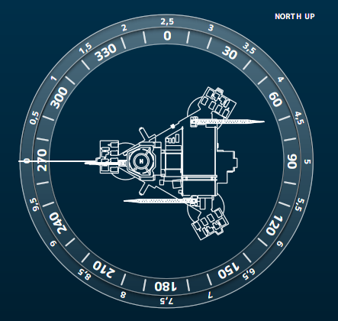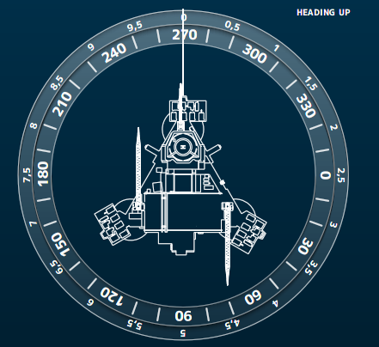

Figure 1‑17: Compass north up and heading up